Chapter 13, Problem 1.

For the three coupled coils in Fig. 13.72, calculate the total inductance.
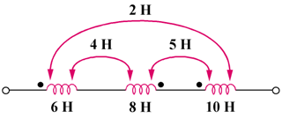
4 H
8 H
12 H
16 H
20 H
10H

Figure 13.72
For Prob. 13.1.

